Travel-aided Information System for the Blind in the Subways

|  |  |
| --- | --- |
|  | Yu Liu |
|  | Jiawen Lu |
|  | Tianze Lyu |
| Supervisor: | Yongneng Xu |
|  | Tangyi Guo |

Nanjing University of Science and Technology

July, 2015

**[Abstract]** The project presents a unique method which offers the blind voice prompt to effectively guide their way through different subway stations. It aims at resolving the current issues that the blind cannot acquire the exact location and relevant orientation information in a timely manner in the subway. This system places passive electronic tags on the“blind bricks”for the blind in the stations, using RFID technology to obtain the location information from these hint points while transmitting the data to his/her mobile terminal via Bluetooth. Finally the App in the mobile phone will launch the application program to determine the current route according to the received location information, and then all the route guides will be broadcast through the Text To Speech synthesis library. This product has been demonstrated to have a lot of potentials in changing how the blind travel and live for many years to come.

**[Key Words]**  the blind, subway travel, RFID tags, voice prompt, mobile terminal

Catalogue

1. Background 5

**1.1.** **Current Situation for the Blind** 5

**1.2.** **Existing Assistant Method Research** 5

**1.2.1.** **Current Status in China** 5

**1.2.2.** **Current Status Abroad** 5

2. Problem Statement 6

3. Proposed Solution Methodology 6

**3.1.** **Available Methods** 6

**3.2.** **Technical Background** 6

**3.3.** **Model Formulation** 7

**3.3.1.** **Design Scenario** 7

**3.3.2.** **Route for the Blind** 7

**3.3.3.** **Definition of RFID Data Frame** 8

**3.4.** **Implementations** 8

**3.4.1.** **RFID Tags on the Bricks** 9

**3.4.2.** **Hardware Integration** 10

**3.4.3.** **Mobile Phone Software** 11

**3.4.4.** **Web Server** 13

**3.4.5.** **Reserved Interface** 13

4. Character and Property Index 13

**4.1.** **Character** 13

**4.2.** **Property Index** 19

5. Innovations 19

5.1. Make use of RFID for guiding the blinds to save the expenditure. 19

5.2. Present a system based on the blind track to simplify the system. 19

5.3. Smart phones make the system convenient for future expansion. 21

5.4. Present a unique design and analysis of route algorithm. 21

5.5. “Internet of thing” provides diversity of intelligent terminals. 21

6. Experimental Results 22

**6.1.** **Version 1.0** 22

**6.2.** **Version 2.0** 22

**6.3.** **Conclusion of Experimental Results** 22

7. Future Prospect 22

**7.1.** **Global Position in Smart City** 22

**7.2.** **Business Application In Smart City** 23

**7.3.** **Future Technology** 23

8. Acknowledgements 23

1. **Background**
   1. **Current Situation for the Blind**

In the fast-developing internet-based society, the community has paid much more attention to the safety of vulnerable groups. With the promotion and popularization of metro in every big city, more and more people tend to choose this kind of transportation which brings people fast and convenient experiences. During the construction of the smart cities, how to help the blind have the same experiences becomes a big concern. Although there have been plenty of barrier-free facilities at present such as the green channel, this problem has not been solved radically especially for the blind. Because of large quantities of cars in the city and nonstandard facilities for the blind, the increasing blind community still fear to go outside, let alone take the subway[1].

In the subway, the blind must seek assistance to be led to the platform as a transit worker meets them at the other end as well. This is a brilliant but not ideal thought because what blind people really need is independence, not dependence.

This led our team to create the much more intelligent assistance tool, a system which combines passive electronic tags on the blind bricks, RFID technology, TTS synthesis library and APP to offer the audio guidance. The goal is to eventually roll it out to larger stations, creating a citywide network that will help the blind navigate the tube independently.

* 1. **Existing Assistant Method Research**
     1. **Current Status in China**

During the sparkling construction of smart cities, lots of methods to solve the guide problems have been put forward home and abroad. In China, for example, Beijing Institution of Technology, Zhuhai used to build a simple guide circuit which can use in their campus[2]. Using SCM to build the whole recognition platform with RFID tags, the prototype seemed to be cumbersome. What is more, Central South University also did studies on the combination of GPS and RFID[3], but the result was not applicable to other fields. Some stations in Shanghai have made the special maps for the blind to touch to get the road information[4] but it is still not easy to expand as the result of different structures.

* + 1. **Current Status Abroad**

While in the London Tube, a system of Bluetooth-equipped beacons guides the visually impaired through the Underground using audio directions. The team just finished a four-week test in Pimlico Station in the southeast of London[5]. The mobile phone receives the broadcast emitted by the Estimote Beacons but it requires high version APP and Bluetooth while our system use RFID, no matter what the version is.

At the same time, some researchers in America also did some studies about NFC tags. They implant these tags in walls, doors, banisters to get the near field communication but the drawbacks are also clear because they need very close distance and huge power consumption. While NUS used to develop a cane that can change direction automatically through a balance beam, but it cannot solve more complicated problem for the blind when they travel in the subway.

1. **Problem Statement**

We got the information from researches that the blind people in China use the stick touching two dots between the route for the blind to help get the location and move forward. Some other traditional guide methods also include guide dogs and ultrasonic canes. On one hand, guide dogs have many limits in public places like subway and shopping malls[6], and the number is not big enough as a result of the high cost for training and maintenance. On the other hand, ultrasonic canes analyze the ultrasonic echo to decide whether there are roadblocks but it is hard to get the obstacle type.

1. **Proposed Solution Methodology**
   1. **Available Methods**

There are now some methods available to help the blind to get independent experience outside such as the cooperation of blind pass and cane, so that we can do better in these aspects. In addition, the blind can also use mobile phones which have the screen reader. We can also work on the mobile phone and think about how to improve the service provided by the metro and how to utilize the internet to help them.

* 1. **Technical Background**

In this smart world, the product also has to be intelligent to catch the trend. The large range of the internet enables everyone to have the chance to experience the advantage brought by the high technology. On the basis of that, we join the latest Internet of Things to obtain better man-machine interaction.

The blind roads give the cane information of location, and then transmit to the mobile phone, which is not in the range of GPS. Then smart phone process different information through its program and give the blind appropriate voice prompt. Internet also plays a big role here. It will send out the help message and route to the subway control room so that the blind can get timely help.

That is to say, when we add the subway system, the whole design can consist of an effective Internet of Things. When the blind go downstairs, subway stuff will know the location of the blind and they can easily go through the turnstile. If we have some support equipment, the subway station can get the location and all the turnstiles and elevators are automatically operated to offer a hand.

* 1. **Model Formulation**
     1. **Design Scenario**

Our system, like the design in figure 1, consists of electrical cane, smart phone with App and they can send information and message to the Internet Server through Internet.

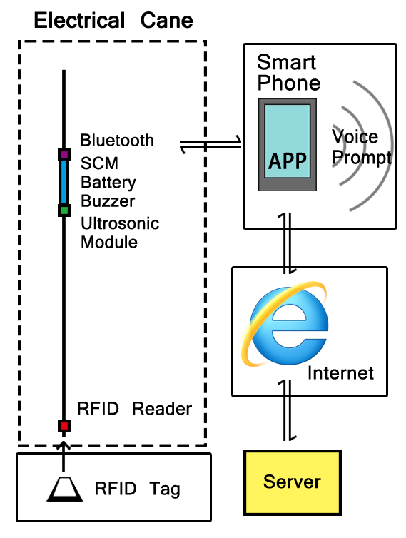

Figure 1 Schematic diagram of different modules

* + 1. **Route for the Blind**

Figure 2 shows relative points in the subway station. Their positions are relatively fixed so that serial number can be confirmed.

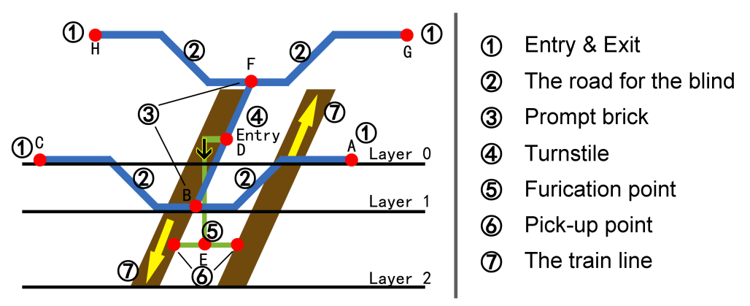

Figure 2 Schematic diagram of the road for the blind in the subway

What is more, in order to improve the program, we divide the cue points among the bricks into three groups. Group 0 are on the ground; Group 1 are in the station hall; Group 2 are on the platform. When the RFID reads from group 0 to 1, it means to get into the station, vice visa. While in the same group, we need to judge the time when the points are read to compute the route and all the basic relationship are stored in the database and server.

This model applies to the route conformation without transference. The system can define explicit route when it gets the start point. When it comes to transference, graph theoretic approach has to be used to acquire the best route for the blind.

* + 1. **Definition of RFID Data Frame**

Every key point has the RFID tags, and data frame is

$$“group \# relative points\# station ID\# IC number\$”$$

# is used to separate data and $ means it is over.

Figure 3 presents not only the RFID data frame, but also interaction process between IC card and App in the smart phone. Data store in the data blocks of IC card in hexadecimal code. When single chip controls the RFID reader to read the information in the IC card, it will transform data into ASCII code and these code make up the data frame. The App can break the package which contains data frame transmitted through Bluetooth protocol to obtain relevant information.

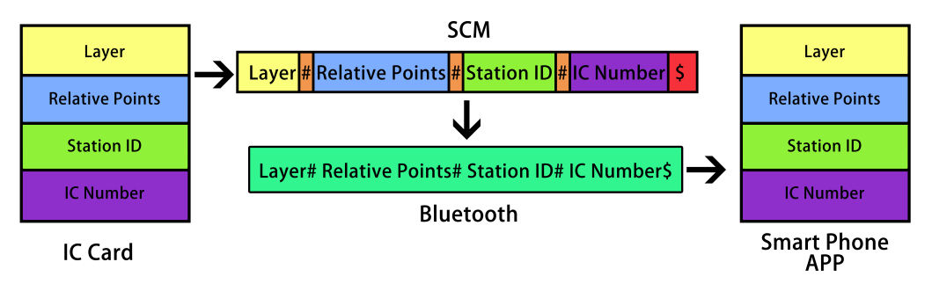

Figure 3 RFID Data Frame and Interaction Process

* 1. **Implementations**

The blind use our smart cane and mobile phone to get the timely and exact location and orientation in the subway. They can easily find their way out according to the voice prompt. The theory is what the following figure 4 depicts.

This system places passive electronic tags on the blind bricks in the stations, using RFID technology to obtain the location information from these hint points, and transmitting the data to the mobile terminal via Bluetooth. Finally the App in the mobile phone will launch the application program to determine the current route including direction and path according to the received location information, and then all the route guide will be broadcast through the TTS（Text to Speech） synthesis library.

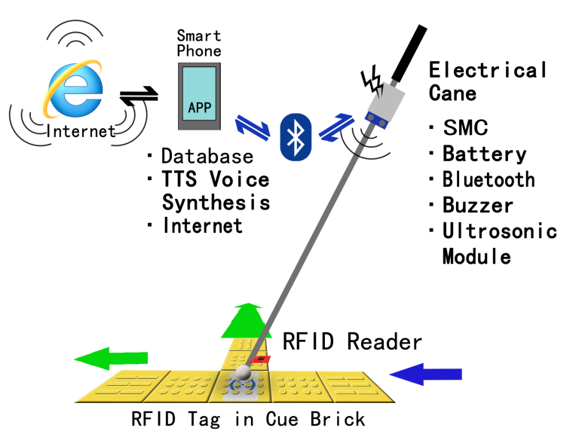

Figure 4 Overall operation process

* + 1. **RFID Tags on the Bricks**

We choose the blind road to put the RFID tags because the blind cannot leave the road very often when they are outside. Since the tags are put on the special bricks, they can enhance the accuracy and decrease cost. The spots which need to be installed are usually bifurcations to acquire best effects. The inner structure of the IC card is like figure 5. One sector consists of four blocks.

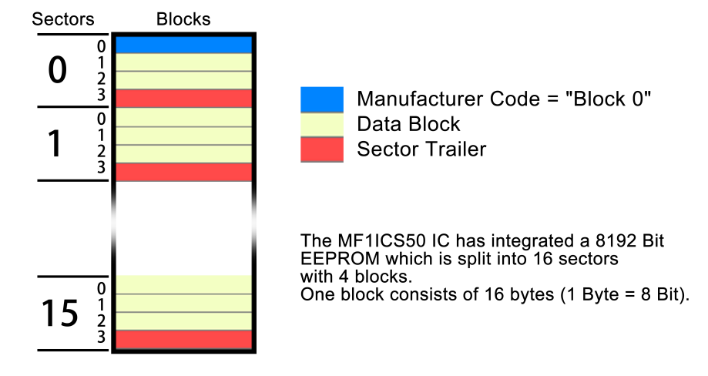

Figure 5 Schematic design of tags

The signal resources on the bricks are mainly aimed at providing accurate and explicit geographic information code which is the unique identification and requires being brief.

The signal resources can be Bluetooth, NFC, RFID and so on. Bluetooth has large range but it has difficulties to orient only according to the strong and weak radios. At the same time, the communication protocol of Bluetooth needs more time to match and connect, so it is not very convenient in this situation which needs rapid information and accurate position. NFC, which means near field communication, is the branch of RFID and it needs particular hardware circuits to launch so it is not very economical. We choose RFID without power to be the signal resource because RFID with power just like NFC. When the IC card uses non-power RFID technology, it can transmit the information in it after receiving and transforming the radios. It is easy to write data in and build the whole system.

The transform design of the brick to put IC card (electronic tags) is just like a small box in which the tags are there to be as large as possible and it is better to be close to the top material, which needs to reflect radios as much as possible. And the structure of installing method shows below in figure 6.

|  |  |
| --- | --- |
| 盲砖交叉点铺设英文 | 提示盲砖示意图 英文版 |
| **T-junction** | **Inner design of the brick** |

Figure 6 T-junction and Inner design of the brick

* + 1. **Hardware Integration**

Hardware is on the blind cane which includes SCM, RFID writer and reader, Bluetooth, ultrasonic module, buzzer, switching circuit and power. All modules connect to SCM.

RFID writer and reader read the IC card and then transmit it to the SCM. The function of ultrasonic module is to alarm when the obstacles are too close to the blind who uses this cane.

Switching circuit is connected to the power supply and controls the state: open or closed. It can also shut down the buzzer if it is too noisy.

Bluetooth transmit the information to smart phone, enabling the communication between two terminals.

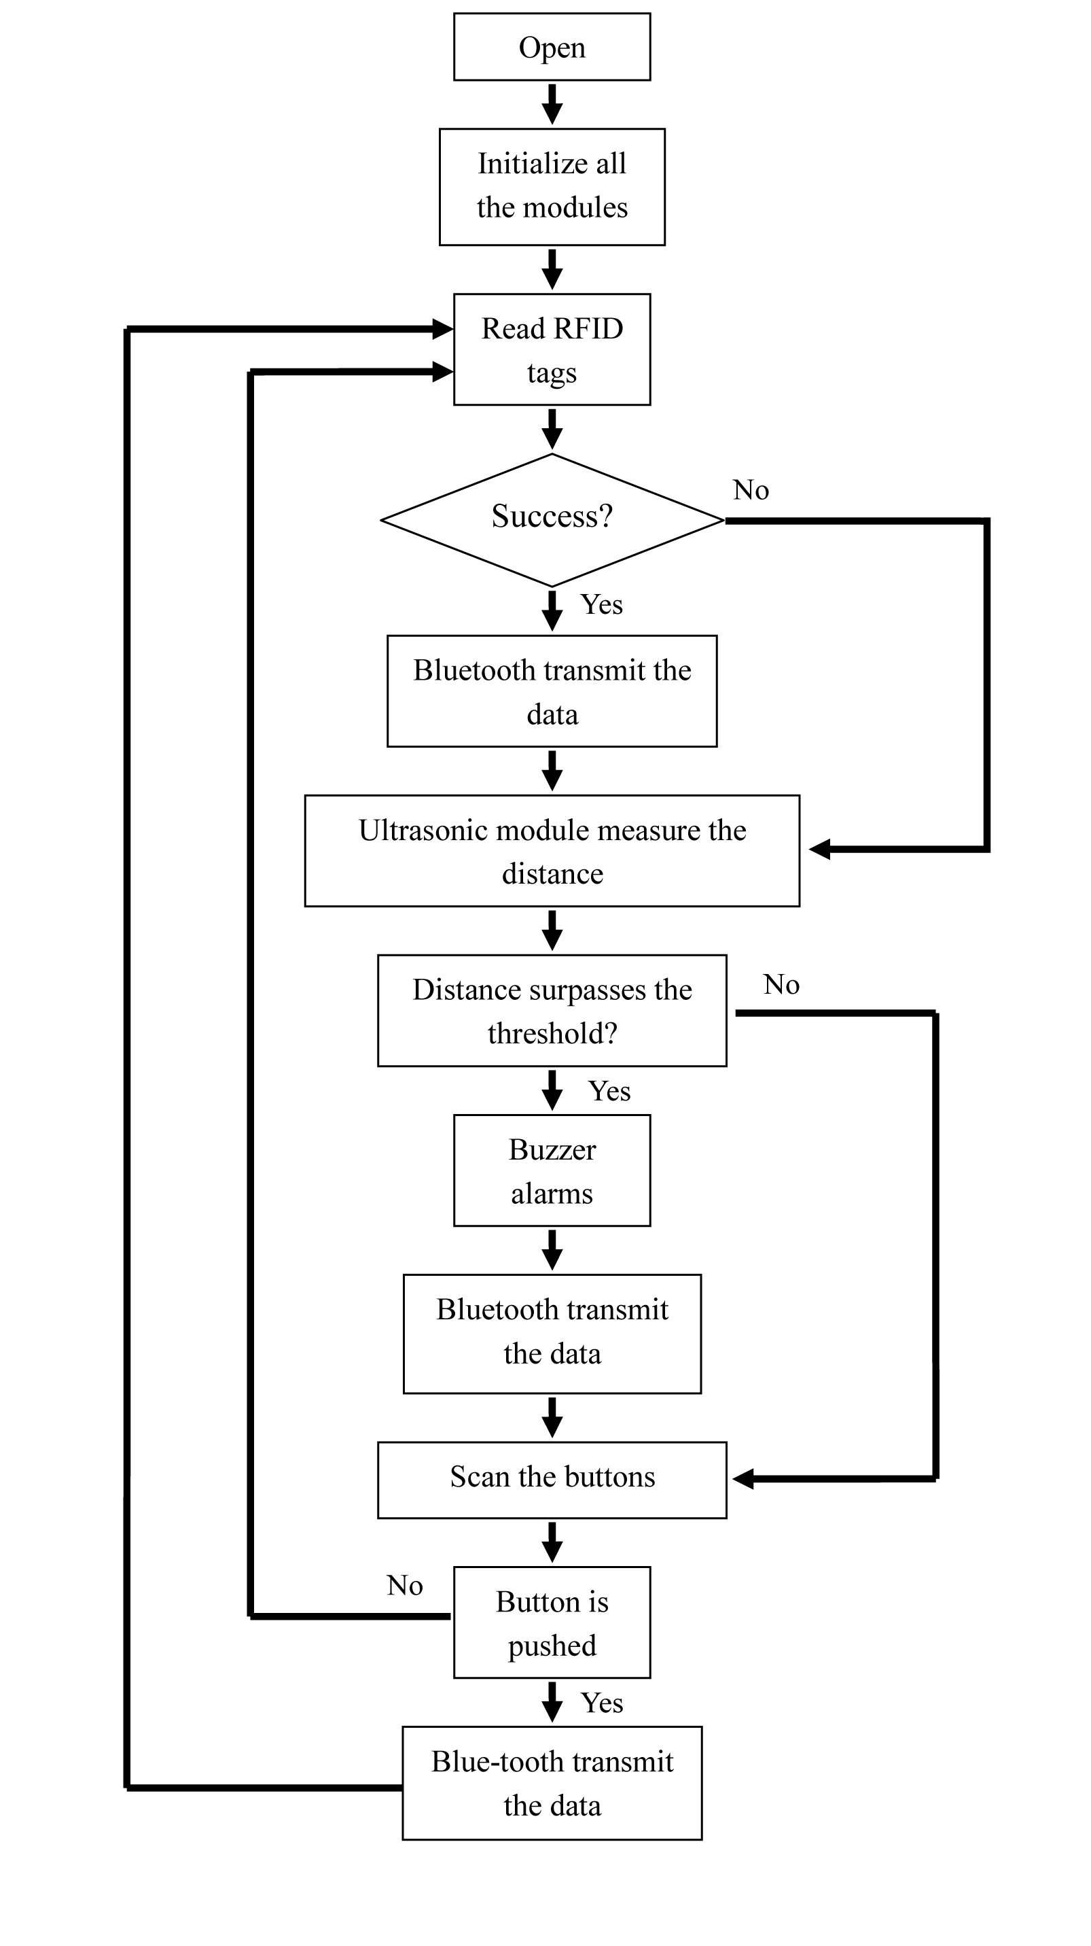

Figure 7 Flow chart of the hardware

The flow chart 7 shows the work flow of the hardware on the electrical cane. The system firstly initial the RFID reader (PN532 module) and the main program starts when the PN532 module is detected. The main program contains three functions: read the IC cards, measure distance and scan the buttons.

The sequence of the main program is as followed:

Step1: Read the geographic information recorded in the RFID cards, if the card is detected then carry out Step2; if not, carry out Step3;

Step2: Read the data in the blocks of IC cards, and then transfer the data into the form of ASCII. Meanwhile, the buzzer sounds in order to prompt. After that, the Bluetooth will transmit the received data, and then carry out Step3;

Step3: Ultrasonic module measures distance;

Step4: The SCM compares the measured distance with the threshold. If the distance data is more than 1 meter, then carry out Step5; if not, carry out Step6;

Step5: The buzzer sounds continuously and the Bluetooth transmits the distance data;

Step6: The main program scans the button to check if any button is pressed. If there is a pressed button, then carry out the Step7 otherwise the program goes back to Step1;

Step7: The buzzer sounds and the Bluetooth on the blind stick device transmit the ID number of the button.

* + 1. **Mobile Phone Software**

The main functions of the APP on the smart phone include receiving information and proceeding, searching and judging operations in database and the following voice prompt. Here is figure 8，the screen of our App when it works.

|  |  |
| --- | --- |
| SAMSUNG-Note3 APP 路径 | SAMSUNG-Note 3寻找设备 |

Figure 8 Screen of the APP

The working process for App is like the figure below. When you click the icon on your smart phone, it will remind you to connect the Bluetooth on your phone to the cane.

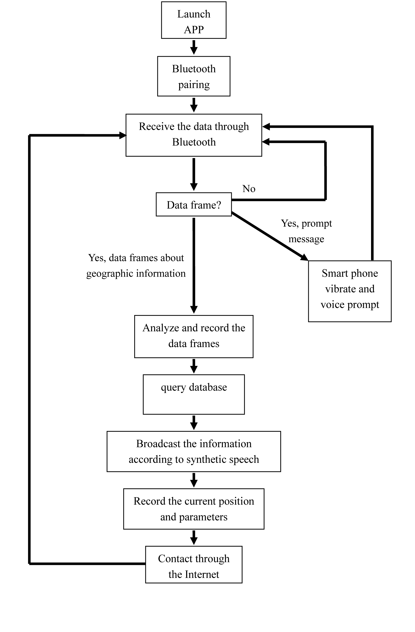

Figure 9 Flow chart of the software

This flow chart shows the work flow of App in smart phone. When the user open the App, the software will broadcast” welcome”. The App is able to offer path analysis and speech synthesis for the blind to guild the way as long as the App connects with blind stick device through Bluetooth technology successfully.

The main program contains four functions. Firstly, receive the data from the Bluetooth of blind stick device. Secondly, analyze the received data. Thirdly, select the received data from database to acknowledge the route of the blind. Last but not least, control the smart phone when it will vibrate and broadcast the geographic information.

The process sequence of the main program is as followed:

Step1: Receive the data from the Bluetooth of blind stick devices. If data are received, then carry out Step2, otherwise order the Bluetooth of smart phones to wait for the transmission;

Step2: Analyze the form of the received data. If the data belong to service data, then carry out Step3. If the data belong to position data, then carry out Step4. If there is no datum is received, then start from Step1;

Step3: The smart phone vibrates to prompt the blind and then broadcasts the synthetic speech according to the received data. The speech includes “asking for help”, “cancel” and “confirm”. After that, start from step1;

Step4: Analyze the position data to find out related position data which is recorded in the RFID tags that are close the blind’s current position and ID number of the current station. After that, according to the received data, the App will select the text that should broadcast from the database of detail position. In addition, the App selects the ID number from the database of station ID in order to acknowledge the name of the station.

Step5: Combine the information that are selected from both database of detail position and database of station ID and then broadcast the information after using text-to-speech technology.

Step6: Record the current position data and station ID, and show the ID and data on the screen and then transmit the data through the Internet. Finally, restart from Step1.

* + 1. **Web Server**

The internet server gathers the data frame from the mobile phone and classifies all the information to store and analyze. The database can change and update itself according to the environment so that it can offer the latest and most effective guide.

* + 1. **Reserved Interface**

Some interfaces are reserved for future expansion. It can add into a bigger system such as Internet of Things as an independent module.

1. **Character and Property Index**
   1. **Character**

The electrical cane is very light and easy to carry. We design a few of simple buttons. It can not only help guide blind people to travel independently, but also ask the staff to help, so it is a very user-friendly design. On the other hand, the whole cost including IC card and the cane for the system is also very cheap, no more than .

* 1. **Property Index**

|  |  |
| --- | --- |
| Norm | Specification |
| IC tag | |
| Chip | $$Mifare 1 S50$$ |
| Size（L、W、H） | $$85.5mm × 54mm × 0.87mm$$ |
| Working frequency | $$13.56 MHZ$$ |
| Memory | $$8Kb$$ |
| Read and write distance | $$2.5cm - 10cm$$ |
| Temperature | $$-20℃-85℃$$ |
| Erase time | $$>100000times$$ |
| Electrical cane | |
| Power voltage | $$9V$$ |
| Electrical quantity | $$4000mAh$$ |
| Device voltage | $$5V$$ |
| Time delay | $$0.7s$$ |
| Weight | $$1.6KG$$ |
| Ultrasonic detection range | $$1m$$ |
| Ultrasonic detection angle | $$120°$$ |
| Bluetooth transmission distance | $$5m$$ |

1. **Innovations**
   1. **Make use of RFID for guiding the blinds to save the expenditure.**

This project makes use of passive RFID tags to storage geographic information which will create an electromagnetic coupling path when the RFID reader comes and then transfer the data inside.

Compared with the navigation system based on the interaction between Bluetooth equipment in station and the blind’s smart phones, these passive tags do not require extra circuit, so they can save the cost of laying cables and power consumption. Due to the advantages of RFID tags and repeated utilization, it certainly has a vast market prospect.

* 1. **Present a system based on the blind track to simplify the system.**

Some available methods using RFID to transmit the geographic information did not determine specific positions for the RFID tags, which makes it difficult for the tags and signals to cover all the place. In order to take the positive impact of blind tracks, our team design the navigation system which is based on the blind track. There are two kinds of blind bricks which called “marching brick” and “cue brick”. When a blind person walks on the blind track, he does not need to judge the direction until reaching a cue brick. So the whole navigation will work well if it can tell the blind present position when he reaches a “cue brick”. Because of the comparatively sophisticated infrastructure for the blind in metro including the blind track, it is possible to guide the blind with high practicability. It decreases the number of IC cards and makes sure that the system is simplified.

* 1. **Smart phones make the system convenient for future expansion.**

At present, some available methods mostly aim at synthesizing SCM, the signal receiving module and the pronunciation module on one smart cane in order to broadcast current geographic information. However, product made in this way is cumbersome and it constrains future functional expansion. But our system adds Bluetooth module on the cane and develops an App that is able to offer path analysis and speech synthesize for the blind to guild the way so it is quite light and handy. Modern smart phones have powerful operation capability, and our App is able to judge the way according to the geographic information received and then broadcast the information to the user by synthesizing the speech through TTS speech database. It simplifies his/her operational process and improves the reliability of receiving the information. With the development of the internet, especially the mobile network, the navigation system can join “Internet of Things” due to the interaction between the smart phones and the servers.

* 1. **Present a unique design and analysis of route algorithm.**

Some available methods using RFID technology or the interaction between Bluetooth and smart phones did not present an effective route design so they cannot analyze the blind’s specific path in the subway station according to the blind track in metro stations. Taking it into consideration, our team made a research on the map of blind tracks in metro and build up a model of the blind route which revolves every probable route of the blind in metro stations because of our flexible route algorithm. On the basis of the unique route algorithm, the App are easy to analyze the blind’s path and offer voice prompt service.

* 1. **“Internet of thing” provides diversity of intelligent terminals.**

The system provides reserved interfaces to build a more intelligent world in the future. It is convenient to connect in the Internet of Things and conduct some analysis of the people’s route choice. It can also be extended to intelligent shoes, intelligent crutches for the old and other approximate areas. So our system will have cheerful prospect as the development of “smart city”.

1. **Experimental Results**
   1. **Version 1.0**

We invited some blind students to use the first generation of the cane product. The results show the area of tags is not big enough so it is not very easy to ensure each tag can be read. So we enlarge the scale of tags and the problem was solved well.

Another drawback is that the alarm in the carriage will bring a lot of trouble. So we design the mute switch.

* 1. **Version 2.0**

After the first test, we improved the cane and the APP. But in the second generation experiment, it is found that blind people use canes too fast, resulting in low rate of reading cards. Since the construction of the subway is not standardized, the ability of correct navigation greatly decreased.

In view of the present situation, we add the help button to seek the help from the subway service center if it is necessary.

* 1. **Conclusion of Experimental Results**

The experimental results of the two generations are worthy of deep reflections. Firstly, the way which the blind used to use the cane cannot be ignored so it is vital to put tags on the cue point and ensure the area to be large enough. In addition, the hardware can still be improved to achieve more efficiency like lower power consumption and higher proceeding speed to meet the user's needs. What is more, for the design of electronic tags, there is also need to update the design to gain more efficient use.

1. **Future Prospect**
   1. **Global Position in Smart City**

In the future development, people will pursue more accurate positioning, especially tracking of children and the elderly, the disabled group and even more extensive tracking of prisoners. At present, the popular technology to locate the position are satellite positioning GPS, mobile phone base station positioning, Wifi positioning, but the accuracy is less satisfactory. After the construction of a comprehensive ground beacon system, as long as the protocol is open, the system can record the location information at any time and then send it to the receiver by the protocol. In addition, some intelligent cars and intelligent wheelchairs can automatically drive according to the beacon. All of these devices constitute the huge traffic information flow, so we can obtain the way people travel such as travel time and travel routes from these data which is a result of better urban planning and transportation construction.

* 1. **Business Application In Smart City**

In the smart city, more and more intelligent products appear in our life. If the beacons can be designed to a certain level of science and technology, it can send the message to customers when he is around the stores where these tags are installed. For instance, when people are waiting for their bus, plane, train, they can get the traffic and weather information. It benefits efficient transportation and better user experience. For indoor installed beacon system, it can cooperate with other security equipment to ensure the housing security.

* 1. **Future Technology**

With the future development of science and technology, there will be blind canes containing more intelligent elements. For example, a visual image front can be transformed into a hand-touch blind map. That is to say, it is the high-density electronic touch screen for the blind. In addition, we can also add the electronic map and other smart functions, so that users have better experiences.

Besides the current system in the metro station, the system can also be extended to the city's comprehensive system of intelligence. It can offer automatic and convenient services for the blind, such as changing the time of traffic lights and broadcast to vehicles to pay more attention to the road when they are on the way. Not only blind stick can use this system but also intelligent crutches, smart shoes, and intelligent wheelchairs. In the development of science and technology, there may appear a new signal source which can wirelessly charge and communicate at the same time. So it is economical and environment-friendly when using it without the use of special power supply.

1. **Acknowledgements**

The authors want to thank Nanjing University of Science and Technology for sponsoring the project “Travel-aided Information System for the Blind in the Subways”. The authors also acknowledge every classmate and teacher for their enthusiastic help.

**Reference**

1. Battier-free way does not satisfy the demand of Disabled persons. (2008) Shenzhen news.Available at:

<http://news.sznews.com/content/2008-08/05/content_3162518.htm>

1. Zhou Tianjian, Wang zhen, Yao Qin,Xu Hongjin Blind Navigation System Based on RFID, China National Knowledge Infrastructure (2011)
2. A navigation system for blinds based on GPS and RFID. State Intellectual Property of The P.R.C (2013)
3. Staff from Tongji University Create Special Maps for The Blinds. China Youth Daily (2015) Available at <http://app.why.com.cn/epaper/qnb/html/2014-10/16/content_225821.htm?div=-1>
4. Guiding The Blind Through London’s Subway with Estimate Beacons. (March 2015) Available at <http://www.wired.com/2015/03/blind-will-soon-navigate-london-tube-beacons/>
5. Measures for the operation and management of Urban Rail Transit. (2005) Nanjing official website. Available at <http://www.nj.gov.cn/njszf/sydw/dt/200911/t20091110_1447286.html>
6. MF1 IC S50 Functional Specification. (May 2001) Baidu Wenku. Available at <http://wenku.baidu.com/view/8f04638d84868762caaed586.html>
7. An invention from Hong Kong university helps the blinds get geography information. (2013) Available at <http://www.kaixian.tv/R2/n2028520c7.shtml>
8. Marko Gargenta ’Learning Android’ Publishing House of Electronics Industry(2012)
9. Dave Smith, Jeff Friesen. Android Recipes A Problem-Solution Approach Berkeley, CA: Apress (2011)
10. Onur Cinar ‘Android Apps with Eclipse’. Berkeley, CA : Apress : Imprint: Apress, 2012.
11. The second Chinese population census of national disabled person. (2006) China Disabled Persons’ Federation. Available at <http://www.cdpf.org.cn/sjzx/cjrgk/200804/t20080407_387580.shtml>